**Nuvoton ISP Programming (USB PORT)**

|  |
| --- |
|  |

1. I connected between Nutiny NUC029SEE EVB and Nuvoton NuMicro ICP programming tool when the Nutiny board is physically connected to PC through USB.

LDROM BIN FILE In BSP: SampleCode/ISP/ISP_USB

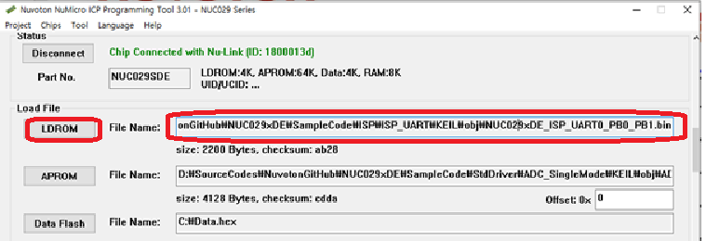

1. Press Settings in Config bits which is indicated with red rectangular form.

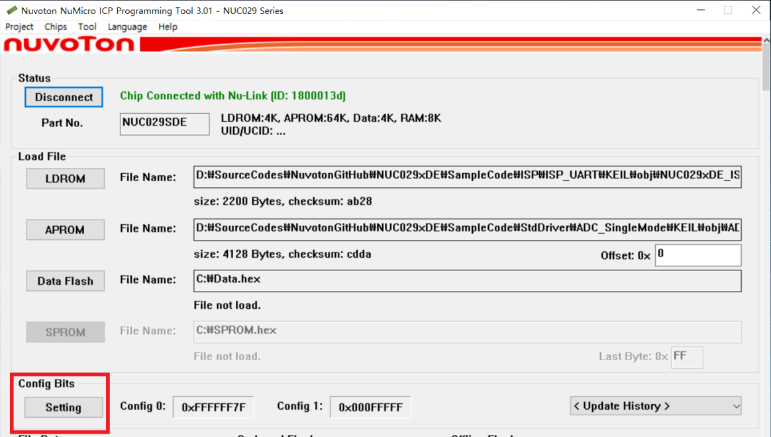

1. Select LDROM in Boot Options

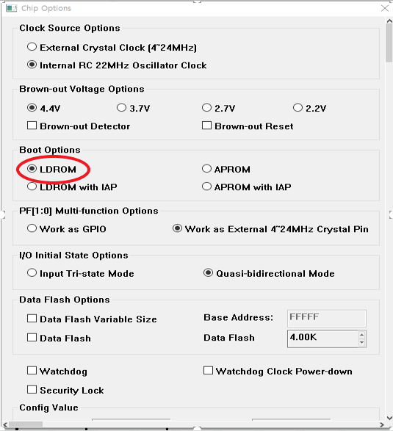

1. Check LDROM and Config Options in Programming Options

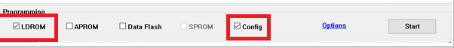

1. The nutiny board, MAIN MCU’S USB interface connect to PC USB PORT. Detect pin keep low state. After reset to run, the MCU will keep in LDROM.

|  |
| --- |
|  |

NuMicro ISP Firmware Flow Chart

|  |
| --- |
|  |

1. Open NuMicro ISP Programming Tool and Select USB in Connection interface because Nutiny board uses USB HID port to communicate with PC’s ISP programming tool.

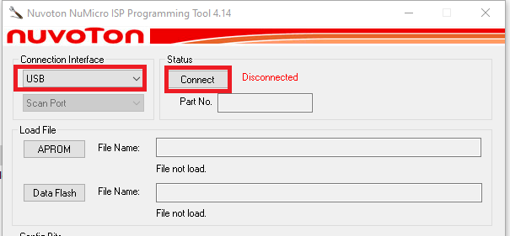

1. Press Start button to program it.

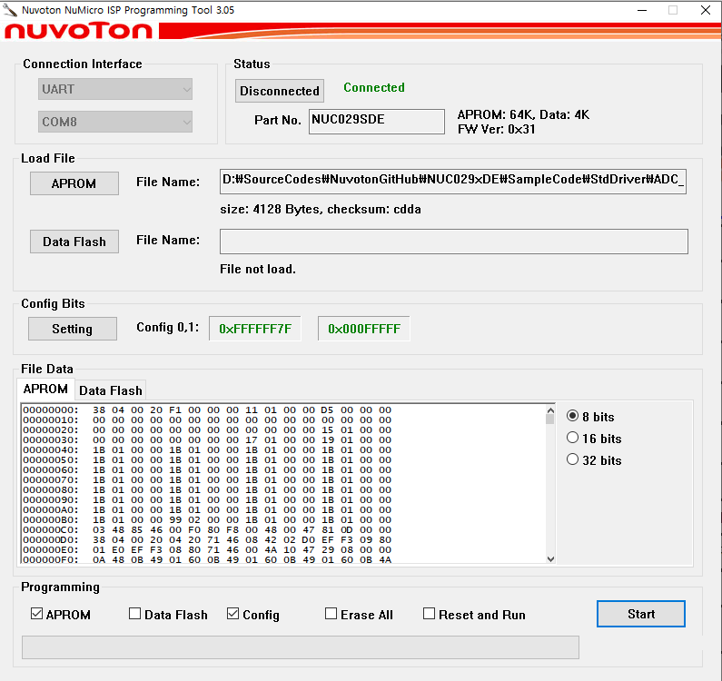

1. See the Programming flash OK screen

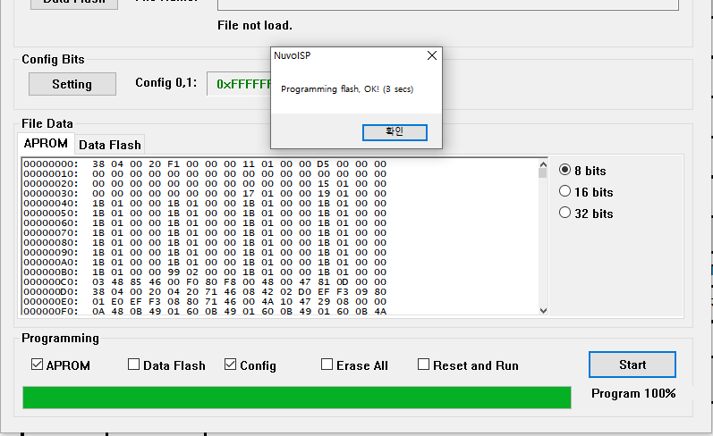

1. Press detect pin is keep high state and press Reset button in the Nutiny board.

**[Summary]**

Use USB port of NuLinkMe to download the ISP_HID binary file to NuTiny NUC029SEE evaluation board.

1) Download the ISP_HID binary file and setting config boot in LDROM by ICP tool.

2) ISP tool select “USB interface” and select connect.

3) Detect pin keep low state and Press Nutiny board reset button for reset MCU and connect with ISP tool.

4)Power on, Detect pin keep high state high state, the MCU will run APROM code.